**Springfield Plateau Chapter -- Missouri Master Naturalist**

**Annual Report -- 2022**

**2022 By the Numbers**

* Number of volunteers that achieved their initial certification in 2022: _**2**_**_**
* Number of volunteers that achieved their 2022 annual certification: _**40**__
* Number of volunteers graduating from a training course held in 2022**: 27**
* Number of active members: **95** _
* Total hours of volunteer service conducted during 2022: **7136**_
* Total hours of advanced training volunteers participated in during 2022: **1023** _
* Total Education Hours: **2103.75**_

**Listing of Local Chapter partners**

Bass Pro Shops Outdoor World Bat Conservation International Organization

Bennett Spring State Park Branson for Monarchs

Greater Ozarks Audubon Society Friends of the Garden

Interpreters Coalition of Springfield and SW Missouri James River Basin Partnership

LAD Fair Leave No Trace National Organization

Missouri Department of Conservation Missouri Prairie Foundation

National Speleological Society Organization Safe Kids Coalition Springfield and SW Missouri

Springfield Plateau Grotto Springfield R-12 School District

University of Missouri Extension Service/Greene County Lakes of Missouri Volunteer Program

Watershed Committee of the Ozarks and Watershed Center White Nose Syndrome Working Group/Missouri

City of Springfield Missouri State University

Springfield-Greene County Park Board Biology Department: Bat Studies

Department of Environmental Services Geology Department: Karst Studies

Department of Public Works Bull Shoals Field

Station

**Springfield Plateau Chapter Projects for 2022 – Overview**

As the COVID threat seemed to subside some, our community, and our Chapter began to cautiously return to in-person activities, eventually, in-person indoor activities. All 2022 Executive Board and Membership meetings continued to be held via ZOOM, in part, due to the element of convenience (perhaps one of the only positive outcomes of the pandemic years). The safety of our members and their families remained our primary concern. Regardless, our Chapter members enjoyed and learned from our excellent selection of programs presented at our “hybrid” membership meetings. Outdoor activities, for the most part, returned to scheduling. School presentations were still, for the most part, on hold, with some exceptions. By year’s end, we had a successful in-person, indoor meeting that was well attended. The ZOOM option for the membership meetings is scheduled to continue through the winter months and will be reassessed in the spring. Members also enjoyed the discovery and fellowship of several field trips, including prairie adventures, wildflower walks, stream sessions and a visit to the Lovett Pinetum and trips to Kipfers’ Bull Mills to explore native plants, aquatic life and even bears and wild pigs!

Members happily returned to our service projects – updates follow. The weather this year was brutal. The “average” rainfall at year’s end was “normal”, but that certainly did not tell the story of the wettest May on record and 6-8 weeks of severe drought and 95+ degree temperatures for days at a time during that period. Averages, after all, are made up of the highest and the lowest numbers and we had both!

**We excitedly welcomed our new Class of 2022!**

Training had been on hold since our last class of 2019. We were very pleased to offer training to 27 interested and passionate trainees. Training included eight classroom sessions and four field sessions, held from September 22 through October 26, with a celebration of graduation on the last night. In addition to the learning opportunities for the trainees, positive exposure for the Missouri Department of Conservation, and the addition of 27 trained citizens to the ranks of our Chapter, amazing memories and lasting friendships are also a lasting benefit of Master Naturalist training.

.

,

*Skulls training*

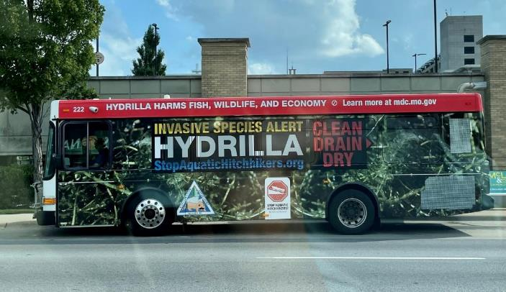

*Catchy bus advertising by our partnering organization City Utilities of Springfield reinforced the invasives component of our 2022 Training.*

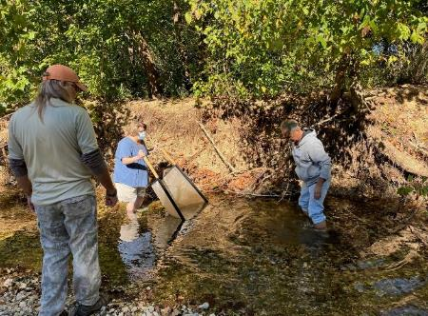

*Aquatics training*

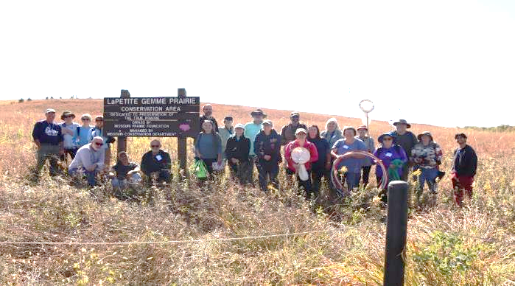

***The Class of 2022!***

**Scholarships – Discover Nature Grants**

In 2022, we resumed our Discover Nature Grant awards, with three grants being awarded to schools and teachers in the Southwest Missouri area. These grants were used to expand an elementary school outdoor classroom, to purchase extra lab equipment for a high school Ecology class Stream Team experiment, and for adding a water feature to a special education classroom sensory garden. Fund raising activities continue in order to support these grants.

**Chapter Promotion**

In addition to a number of in-person opportunities, we continue to promote our Chapter and the Master Naturalist program via our blog, website, and Facebook page. Our Chapter Blog, posted by head blogger, Bob Kipfer, continues to inform and entertain loyal followers and attract new viewership. At the end of 2022, a total of 35 blogs were presented for the year. Blog at [Springfieldmn.blogspot.com](http://Springfieldmn.blogspot.com) Shae Johnson, our Wizard of the Web, assisted by Andrea Taylor, continues to maintain our site, giving site visitors a valuable resource for information both about our Chapter, the Master Naturalist Program, and interesting and often unusual nature topics.

In-person participation included: tabling at the Ozark Society “Year of the Rivers” Conference, Friends of the Garden Butterfly Festival, Homeschool Outdoor Fair sponsored by the Interpreters Coalition and others.

**Educational Programming – the WOLF School –**

Our Chapter continues our support of the WOLF School, with both in the classroom plus field trips.  WOLF (Wonders of Outdoor Learning Facility) is a partnership between Bass Pro and Springfield Public Schools with approximately 50 students and two teachers presenting the full year of the standard 5th grade curriculum “taught through the lens of nature.” One of the first such facility of this type in the nation, the WOLF School continues to provide exceptional educational opportunities and experiences wide popularity and respect. It has served as the prototype for two additional new targeted learning opportunities in the Springfield Public School System. Dr. Bob and Barbara Kipfer continue teach at the WOLF School weekly as well as selected field trips. MN’s are also called upon for selected areas of expertise.

WOLF students enjoyed this year’s field trip and Missouri Black Bear sessions in the classroom.

**Education Programming with the Missouri Department of Conservation – Missouri Master Naturalist Junior Leader Program**

Although some activities in schools continued to slowly increase, the Missouri Master Naturalist Junior Leader Program remained on hold. In the meantime, communication between the Chapter and interested schools and students continued, as well as social media posts, hoping to hold their interest until the program can become active again.

**Educational Projects from Adventure Backpacks to Bisons**

**Adventure Backpacks** is a new in 2022 project for our Chapter. Funds donated by our Chapter allowed the Springfield Greene County Library to increase the number of Adventure Backpacks available to check out.  The backpacks have supplies and tools to explore the great outdoors, a nearby park or a backyard.

*Examples of Backpack Materials*

**Educational Presentations –**

Chapter members responded to, once again return to in-person classroom presentations on a case by case basis, much to the delight of the students and teachers. The Bison Presentation is one of our most popular offerings.

**Exciting Project Showcases Collaboration with local Municipal Utility -- Update**

In 2019, members of our Chapter met with representatives of City Utilities (CU) of Springfield, our community’s publicly owned utility, to discuss a collaboration to start City Utilities on a path to using CU right-aways to benefit pollinators and reduce use of herbicides and mowing. This led to a demonstration plot project at the CU Solar Farm, at the time, the largest such facility in the State, with planting taking place in the Spring of 2020. A rain harvesting system, including a rain barrel, was installed to water the plants and demonstrate the practicality of using rain barrels for plant maintenance.

Plentiful summer rains kept this native landscape well-watered, and a couple of visits to remove thistle and Bermuda grass, as well as blue fescue that escaped into the sidewalk cracks, kept the bed maintained. Late September this year, a spurge established itself and smothered out some rose verbena. Weeding got the spurge out of the bed, which we suspect came about via birds in the area feeding on the native seeds in the bed, as there was no evidence of this plant in the adjacent fields. <https://www.missouriplants.com/Euphorbia_dentata_page.html>

**Lake Springfield Park Boathouse Project – Update**

This is an ongoing project for a dedicated group of our members. Lake Springfield Boathouse (a facility of the Springfield-Greene County Parks Department) received funds to renovate the flower beds around the balcony area of the Boathouse. This renovation created new beds that feature native trees, shrubs, plants and grasses and will educate patrons with plant labeling.  Additionally, this new landscape provides an attractive place for photos to be taken since the Boathouse is a popular venue for a variety of events including weddings and family gatherings.  The Master Naturalists helped create the landscape design as well as purchased and planted many of the native perennials.  During the growing season, we continue to maintain this new area as well as several other native beds adjacent to the Boathouse.  Next year, we will see more maturity in this landscape.

*Boathouse Showcase Photos*

**Missourians for Monarchs**

Our Chapter continues to remain actively involved in activities supporting the creation and preservation of habitat for Monarchs and other pollinators, participating in our own projects and activities as well as supporting and participating in those of our various partners.

**Bonniebrook – A New Project for 2021**

Bonniebrook is the historical homestead of Rose O’Neill, a famous artist, writer, sculptor and creator of the Kewpie. Efforts are underway to restore the gardens at Bonniebrook by planting native plants. Springfield Plateau Chapter continues to support these efforts with volunteers and funding for plants and supplies.

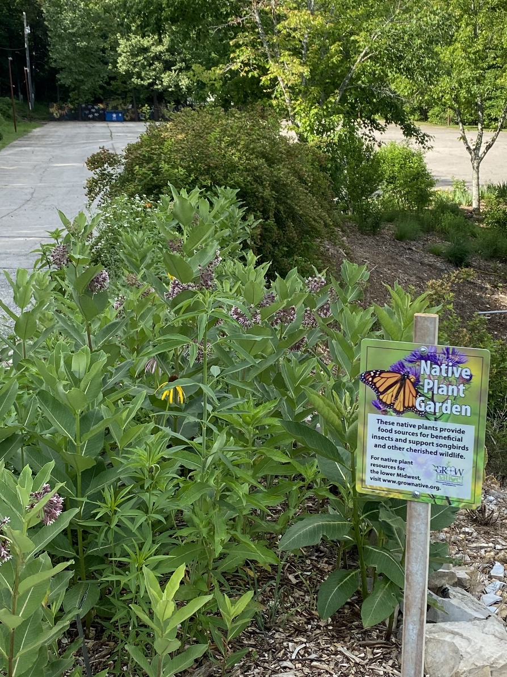

*Milkweed thriving at the Bonniebrook site*

**Overachievers Abound in the Springfield Plateau Chapter**

As members of our Chapter, we are very proud of our Chapter’s accomplishments – it is truly a team effort. From time to time, members in our Chapter receive “outside” recognition for their individual accomplishments and efforts. A few of these well-deserved recognitions include:

**Holly Welch, Chapter President-Elect, 2022** was recognized.

Bennett Spring seasonal naturalist Holly Welch was presented with a Masterpiece Award she received for being the “Seasonal Employee of the Year.” Holly received the award for her outstanding work putting together a video that focused on the historical aspects of the area that became Bennett Spring State Park. The video was shown on opening day of trout season and continues to be shown in the Nature Center. Also noted in the nomination was Holly’s willingness to take on many projects including caring for snakes, providing extra coverage at the Nature Center, and just overall being a great team player with a very positive attitude. Holly was nominated for the award by Patricia Chambers, naturalist at Bennett Spring State Park.

*Pictured from left to right: Hayley Schnaath, Gabriel DuMond, Holly Welch (receiving award), Laura Hendrickson, Patricia Chambers, Debra Ebersold, Caleb Welch.*

**Dr. Bob and Barbara Kipfer were honored with National Conservation Special Achievement Award from the National Wildlife Federation.**

The National Wildlife Federation honored Bob and Barb Kipfer with its National Conservation Special Achievement Award. The award recognizes the multitude of ways the Kipfers have offered their time and resources for education, community engagement, land restoration and wildlife conservation.

The Kipfers own 400 acres of land in Christian County, Missouri which they have used for hosting forestry conferences, providing charity firewood, helping with bird counting and planting seedlings in riparian corridors. The Missouri Department of Conservation has tracked black bears and trapped wild hogs on their land while Missouri State University studies stream ecology and woodland management.  They write a conservation blog and teach weekly conservation sessions at the Springfield Public Schools 5th grade Wonders of the Ozarks Learning Facility.

“The success of the conservation movement depends on responsible land ownership and the Kipfers are a shining example of how to embrace the ideals of conservation,” said [Collin O’Mara](https://protect-us.mimecast.com/s/BjxGC73nw5cE1YYAHAeU2z?domain=u7061146.ct.sendgrid.net), president and CEO of the National Wildlife Federation. “Their commitment to best practices and openness to community groups, conservation organizations and research institutions has turned their land into an invaluable resource for people and wildlife, alike.” “We are honored to receive this award and want to thank the Missouri Department of Conservation and all the other organizations whose resources and support of us have made it possible,” said Bob Kipfer. “To become passionate about the natural world you first need to learn enough to love it, and you are never too old to learn.”

The Kipfers have previously been recognized as State Tree Farmers of the Year and as the Missouri Conservation Federation’s Conservationists of the Year. Going forward, the Kipfers have a 50-year protected agreement with Missouri State University where their land will continue to sustain the natural ecology and be used for continued education after they are no longer able to manage it.

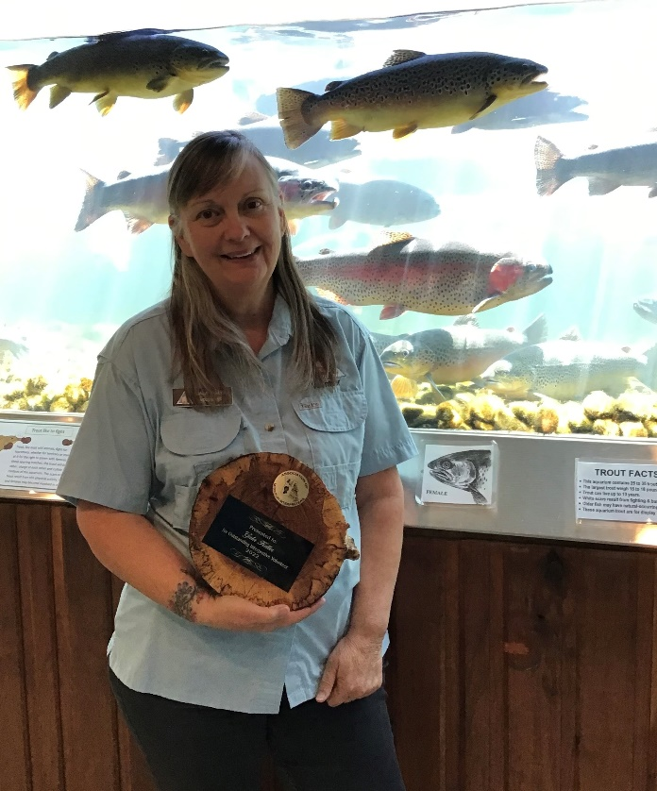**Gala Keller received Association of Missouri Interpreters Award.**

Gala recently received the “Outstanding Interpretive Volunteer” award for 2022 from the Association of Missouri Interpreters. It was in recognition of a series of three virtual programs at Shepherd of the Hills Hatchery and Conservation Center. In each program, I instructed participants in painting Missouri State Symbols- 1) Eastern Bluebird, 2) Flowering Dogwood, and 3) American Bullfrog. During breaks in each program, a naturalist shared information about the subject we were painting. Shepherd also won the AMI award for “Outstanding Interpretive Effort” 2022. They were all pleased to be recognized!

**Linda and Mark Bower – this brother/sister duo continues to amaze us!**

These two dedicated and talented members have chosen the visual arts for their educational medium. In 2022, Mark completed his latest beautiful book of photographs: Mushroom of the Missouri Ozarks. In addition to being a published author/photographer, he continues a photographic mushroom survey at Valley Water Mill Park. Since 2013, each year or two, he updates a book of mushroom photos and descriptions and donates it to the Park’s Educational Center. The book now has 238 pages and contains over 300 species. An example of Mark’s work:

Linda Bower has chosen videography as her communication tool. As an example, her Pondering the Missouri Pond, a part of her Nature in Motion Video series, has been recognized and enjoyed:

* YouTube channel, Nature in Motion Videos, has gained 1.2 million views with over 24,000 watch hours. Videos include pond and garden wildlife from the Missouri Ozarks.
* Spotted Salamander video was included in the documentary, Great Lakes Untamed, which aired on the Smithsonian Channel and is now available on Paramount+.
* Presented Pondering the Missouri Pond for the new MN class and the Watershed Committee’s monthly meeting. The presentation uses video evidence showing that ponds sustain wildlife that is healthy, diverse, unique and wide-ranging.

**Barbara J. Lucks Scholarship for a Sustainable Future is awarded for the first time**

Our Chapter’s long-time Treasurer, Barbara Lucks, has endowed the first student scholarship for the new Sustainability Major at her Alma Mater and one of our Chapter partners, Missouri State University. Having served on the University’s Sustainability Advisory Committee since its inception and having earned international certification in the inaugural class of the International Society of Sustainability Professionals, she welcomed the opportunity to endow the first scholarship in the new major. The scholarship is targeted to first generation students from rural backgrounds with a commitment to sustainability.

**Our Work is Never Done**

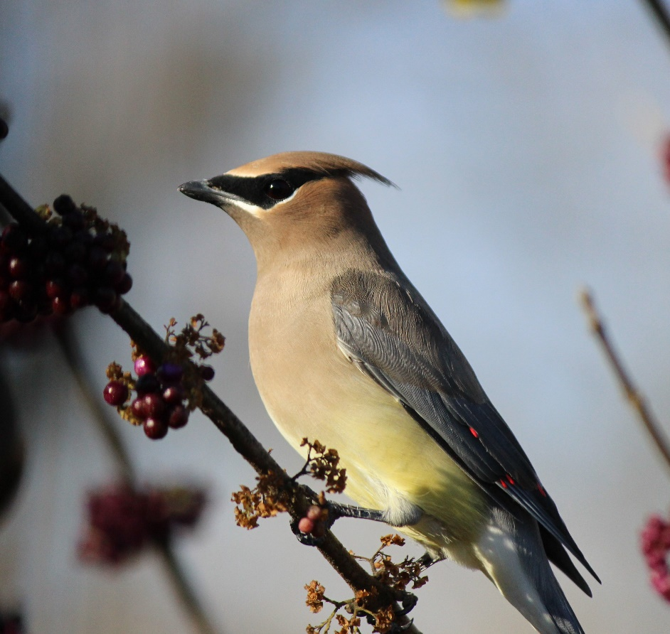

While our Chapter does not commit the entire Chapter to ongoing projects, we encourage our members to feel free to volunteer for projects that are or may become more than a one-time effort. As one might imagine, our energetic and talented volunteers have many exciting opportunities from which they can choose. Some of these projects have evolved into lasting educational opportunities (both ways – to learn and to give), long-term friendships, as well as valued partnerships.

These include, for example, the Watershed Center at Valley Water Mill with our partner the Watershed Committee of the Ozarks; the GLADE Project with our partner the Greater Ozarks Audubon Society; service at the Springfield-Greene Botanical Gardens and Center, including the Butterfly House, which raises caterpillars and provides excellent hands-on educational opportunities for all ages, but with a special nod to the children. Several of our Chapter members have been serving as docents, and, combined with the curators’ (also Chapter members) hours, well over 2,000 education hours have been provided by Chapter members to the facility whose visitor count is in the tens of thousands each year.

**And, we continued to hone our newly-acquired electronic skills and welcomed the opportunity to enjoy the simple act of gathering, visiting and enjoying the fellowship of sharing food and friendship with a newly-found appreciation!**

**Springfield Plateau Master Naturalist Mission:**

Our Mission is to engage people in the stewardship of our state’s natural resources through science-based education and volunteer community service. [www.springfieldmasternaturalist.com](http://www.springfieldmasternaturalist.com)

**Program Objectives**:

1. Improve public understanding of natural resources ecology and management by developing a pool of local knowledge about natural resources ecology that can be used to enhance education efforts within local communities.
2. Enhance existing natural resources education and outreach activities by providing natural resources training at the local level, thereby developing a team of dedicated and informed volunteers.
3. Develop a self-sufficient Missouri Master Naturalist volunteer network.

**Our Sponsors:**

